

**Name: Manoj Kumar**

**Dept: Information Technology**

**Roll No: BIT-24S-023**

**Subject: Artificial Intelligence**

**(LAB TASKS)**

**LAB #01**

Q. MAKE 2 -2 PROGRAMS OF EACH DATA TYPE

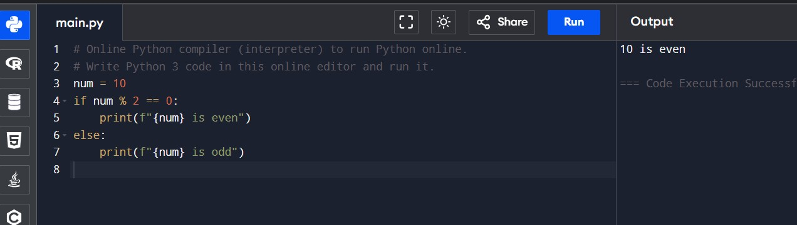

Q. MAKE UP TO 5 SHAPE PROGRAMS USING

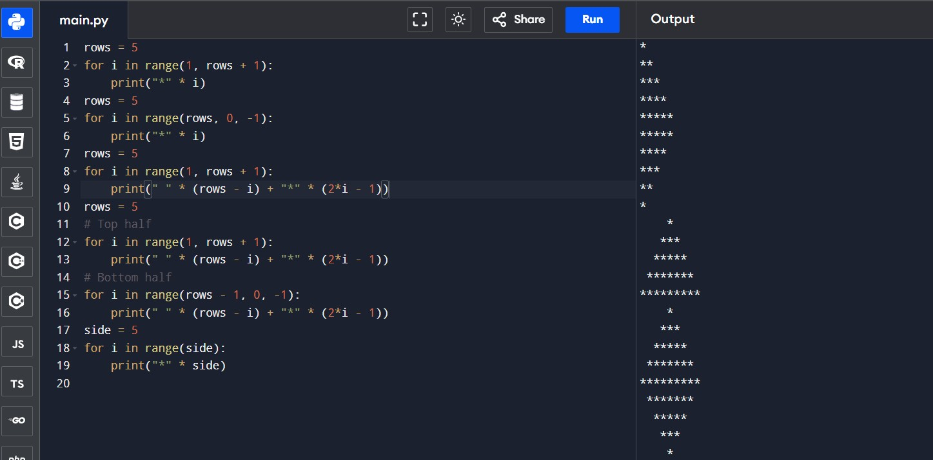

Q. MAKE SAME SHAPES YOU HAVE MADE IN TASK 2 USING * MULTIPLE BY NUMBER

**LAB # 2**

Q. Print numbers from 1 to 10 using a for loop.

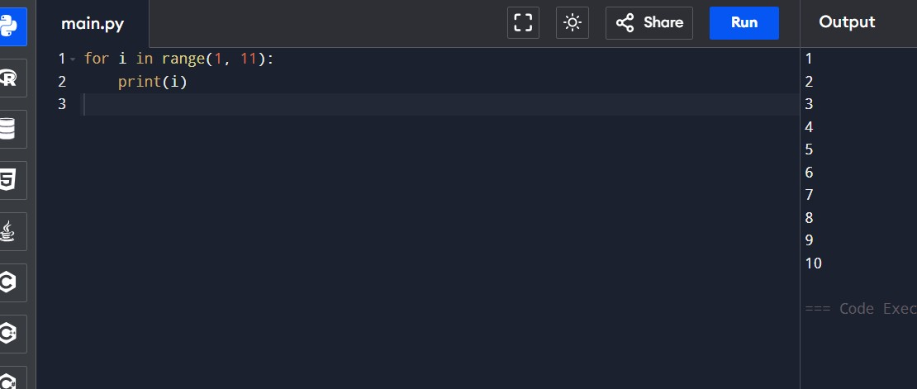

Q. Print all even numbers between 1 and 20 using a while loop.

1. Calculate the sum of numbers from 1 to 100 using a loop.

1. Print the multiplication table of 5 using a loop.

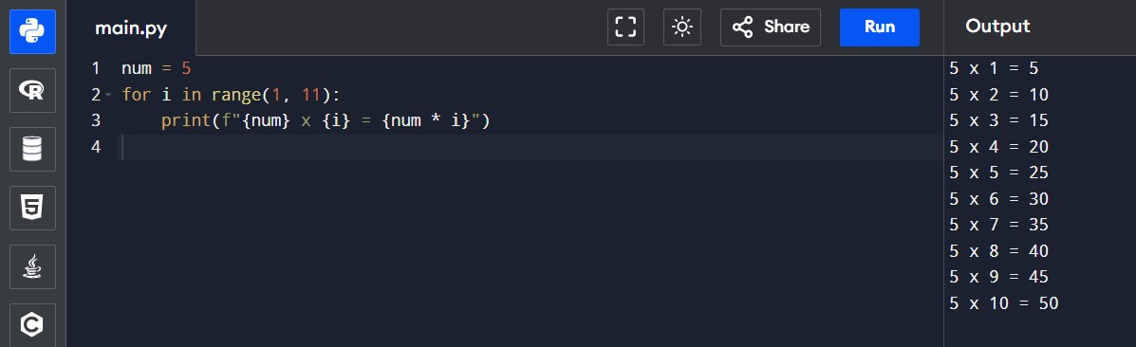

1. Find the factorial of a given number using a for loop.

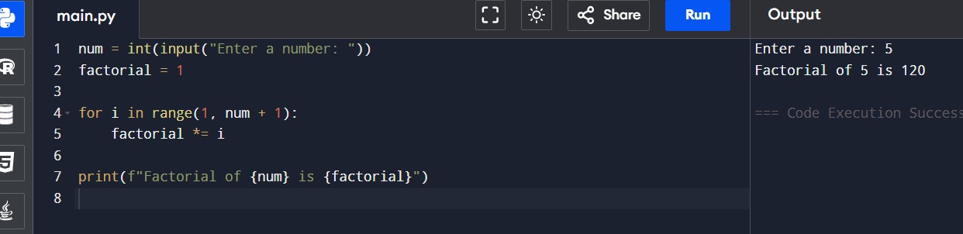

1. Iterate over a list of fruits and print each item.

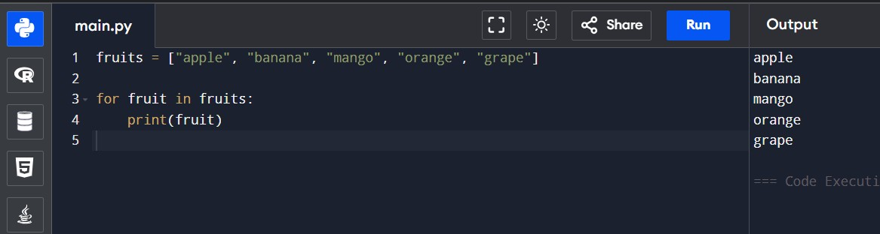

1. Create a list of numbers and print only the odd numbers using a loop.

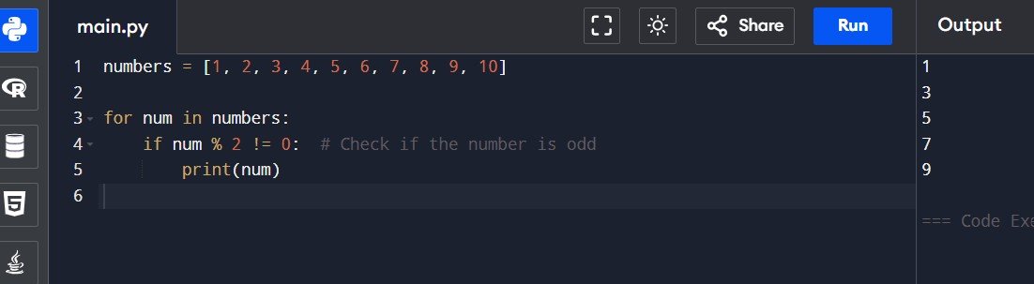

**LAB 04:**

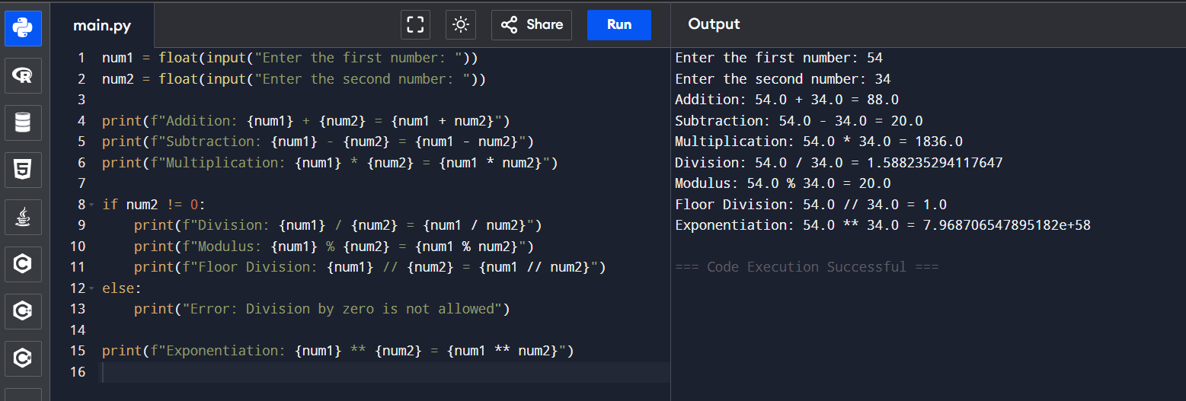Q. Write a python program to take two numbers as input and perform all arithmetic operators on them.

Q. Create a function that takes two numbers & returns their sum-sub-product-division.

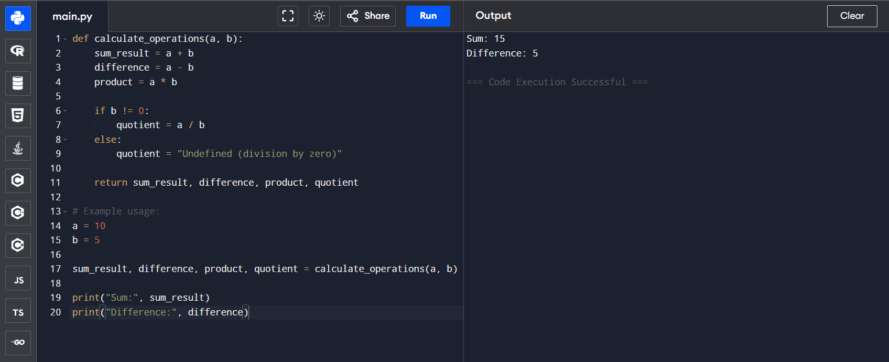

Q. Write a python script to find the remainder when one number is divided by another.

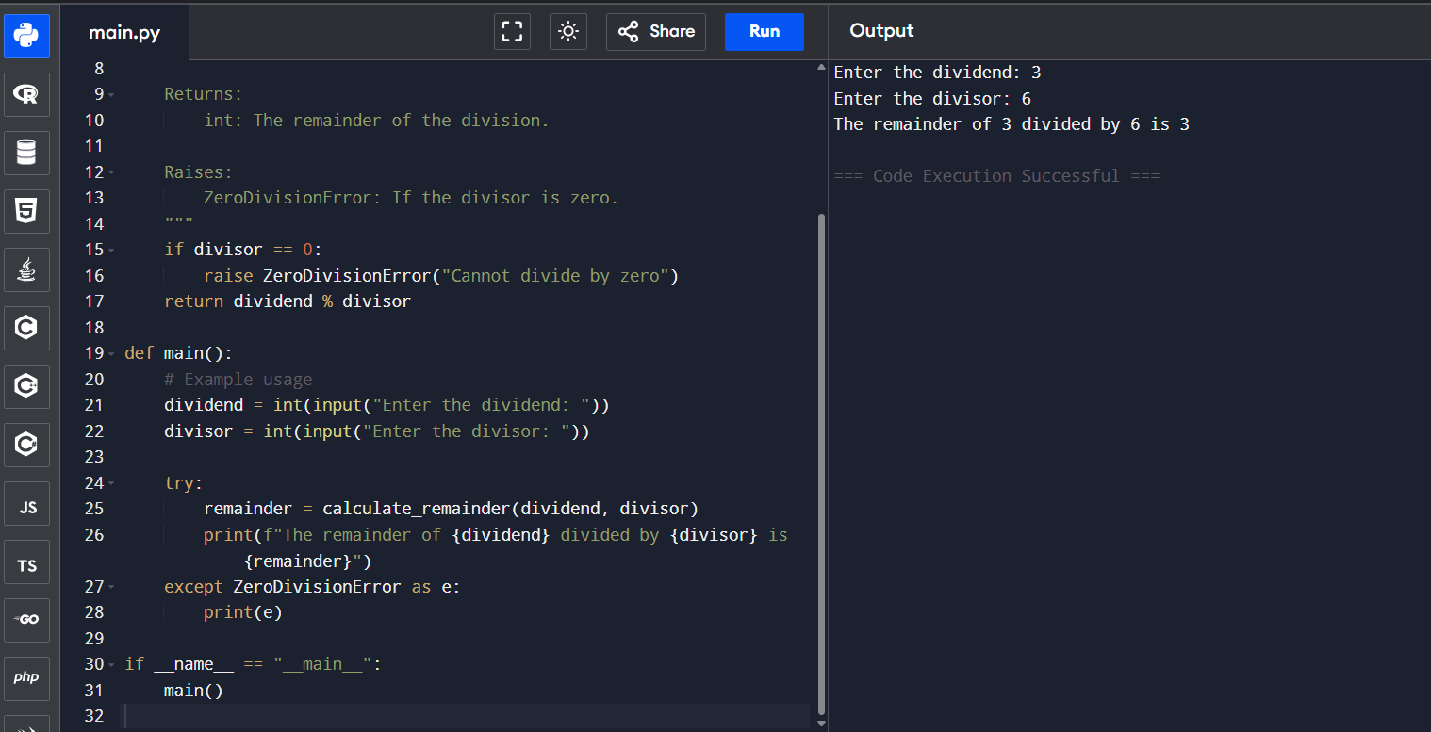

Q. Write a program to calculate the area of circle using the formula

(Area =π*r^2).

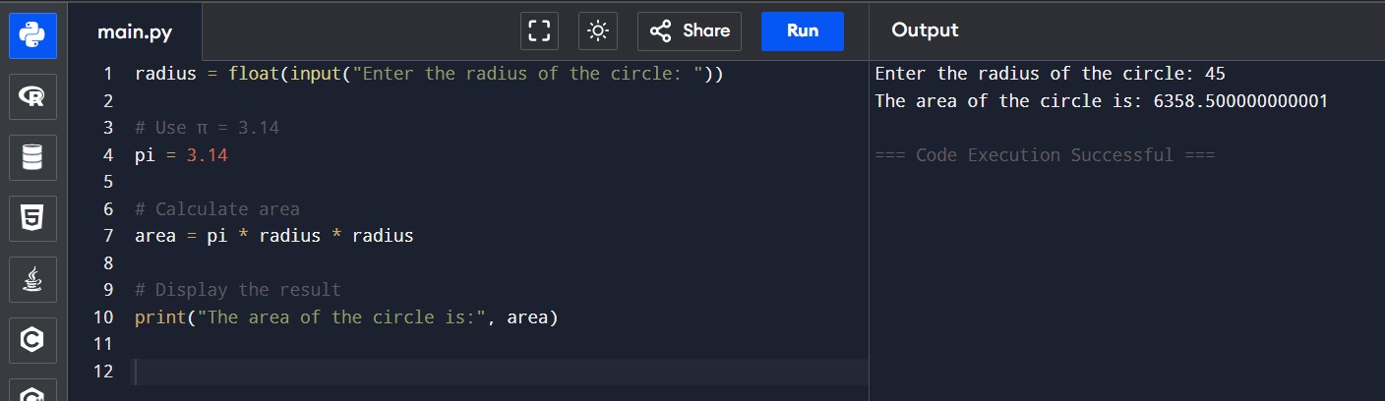

Q. Implement a program that takes a number as input & returns its square & cube using exponential.

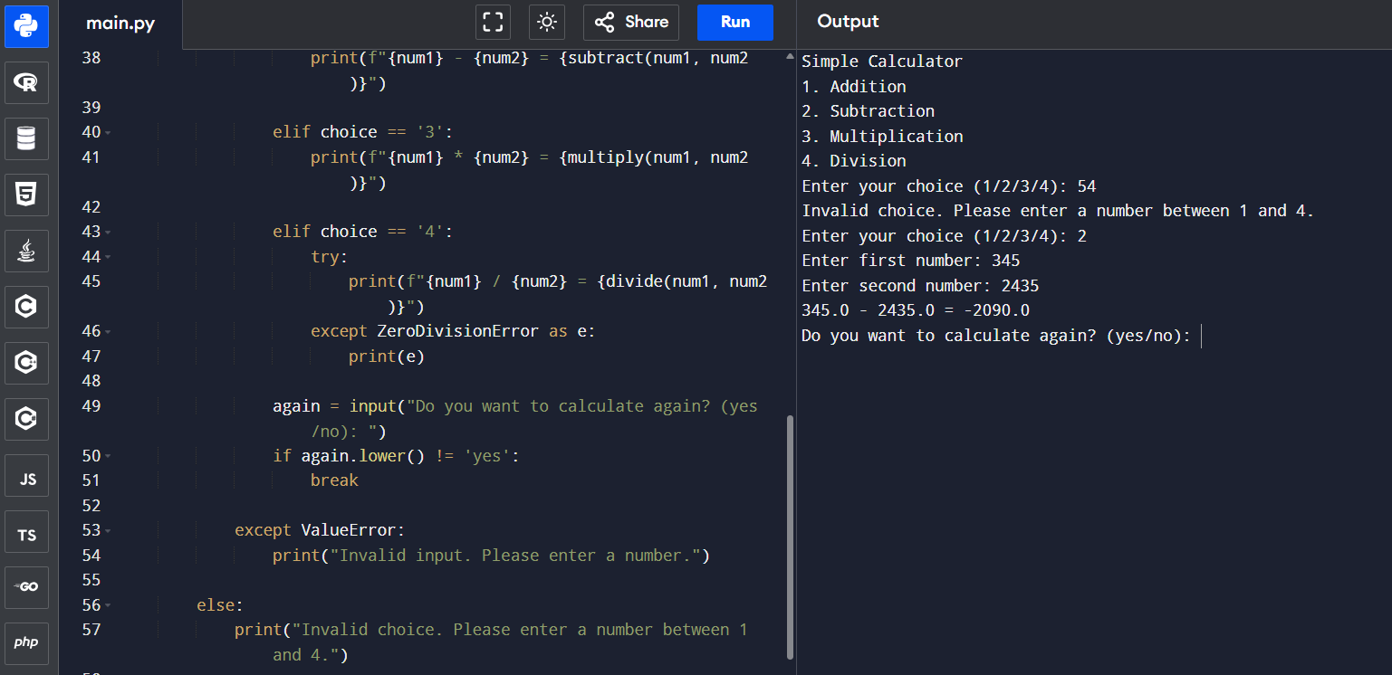

Q. Create a simple calculator in python that allows the user to choose an operation (addition, subtraction,etc) & inputs two numbers.

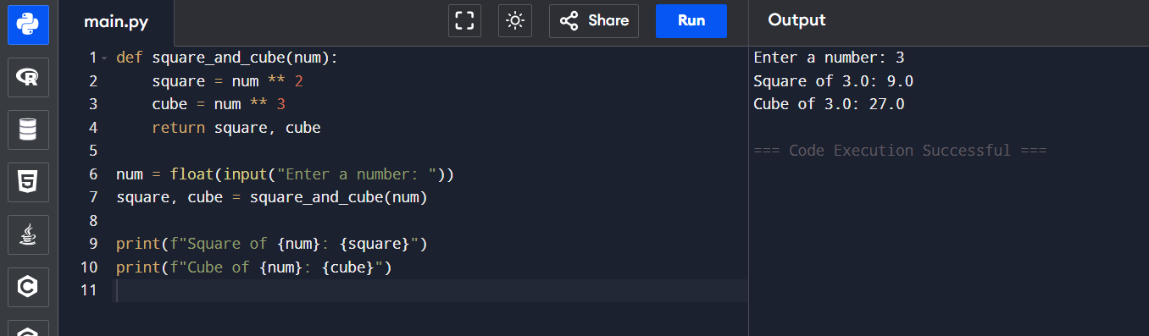

**LAB 05**

Q. Write a program that checks if a given number is positive, negative or zero.

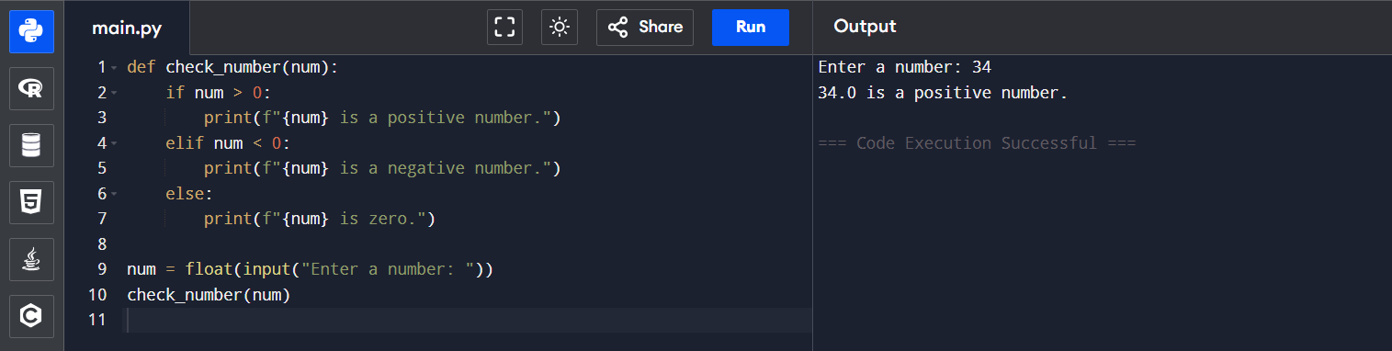

Q. Write a program that takes user input & determines whether it’s an even or odd.

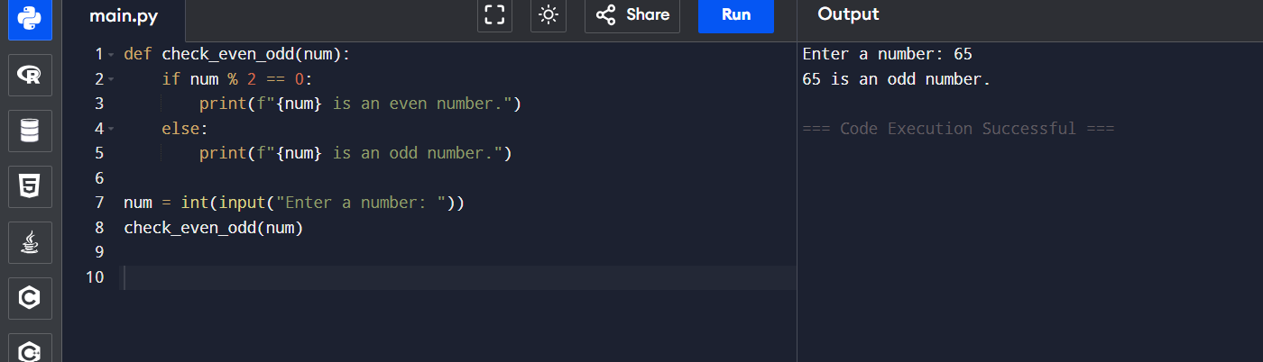

Q. Create a program that takes asks user to print

“excellent” if marks are above 80

“good” if marks are between 60 to 80

“needs improvement” if marks are below 60.

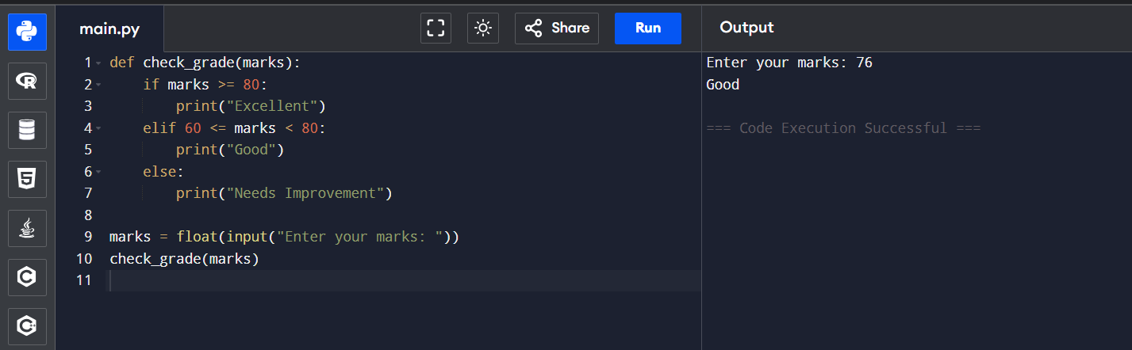

**LAB 06**

Q. Write a for loop to print the first 10 natural numbers.

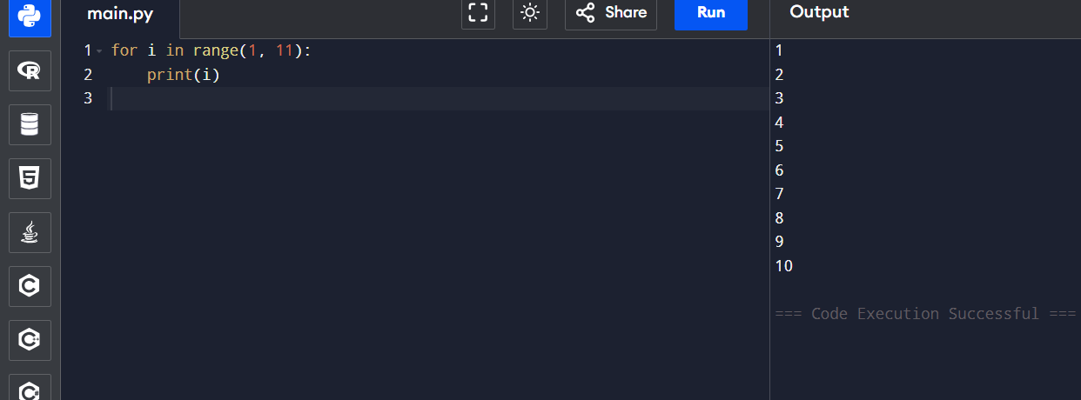

Q. Write a while loop that prints numbers from 10 down to 1.

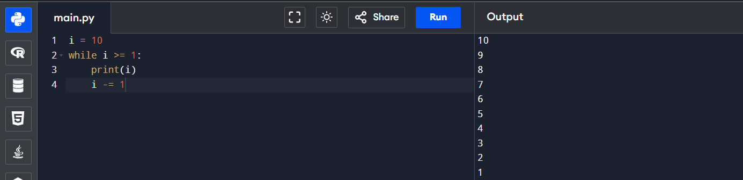

Q. Create a program that uses a for loop to iterate over a string & count the number of a vowels.

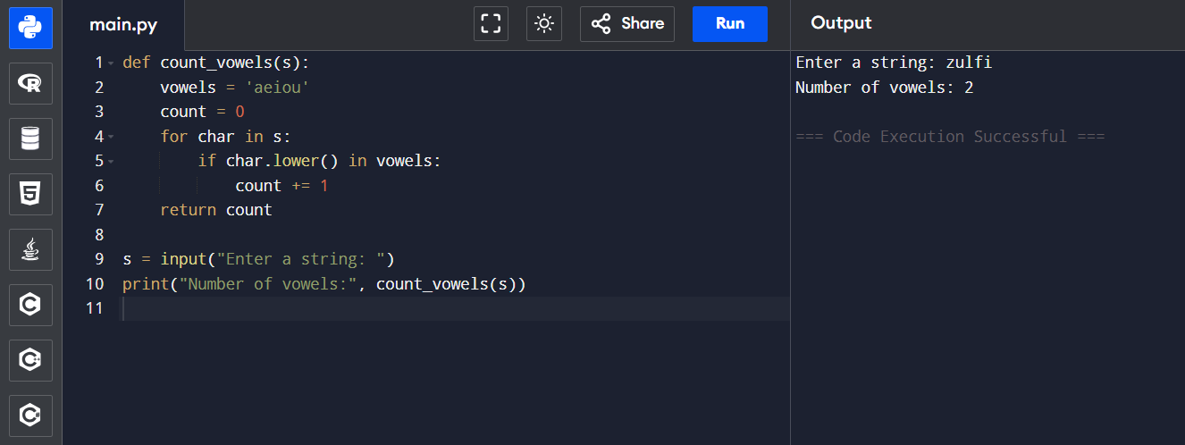

Q. Write a program that prints the Fibonacci series up to n terms using a while loop.

